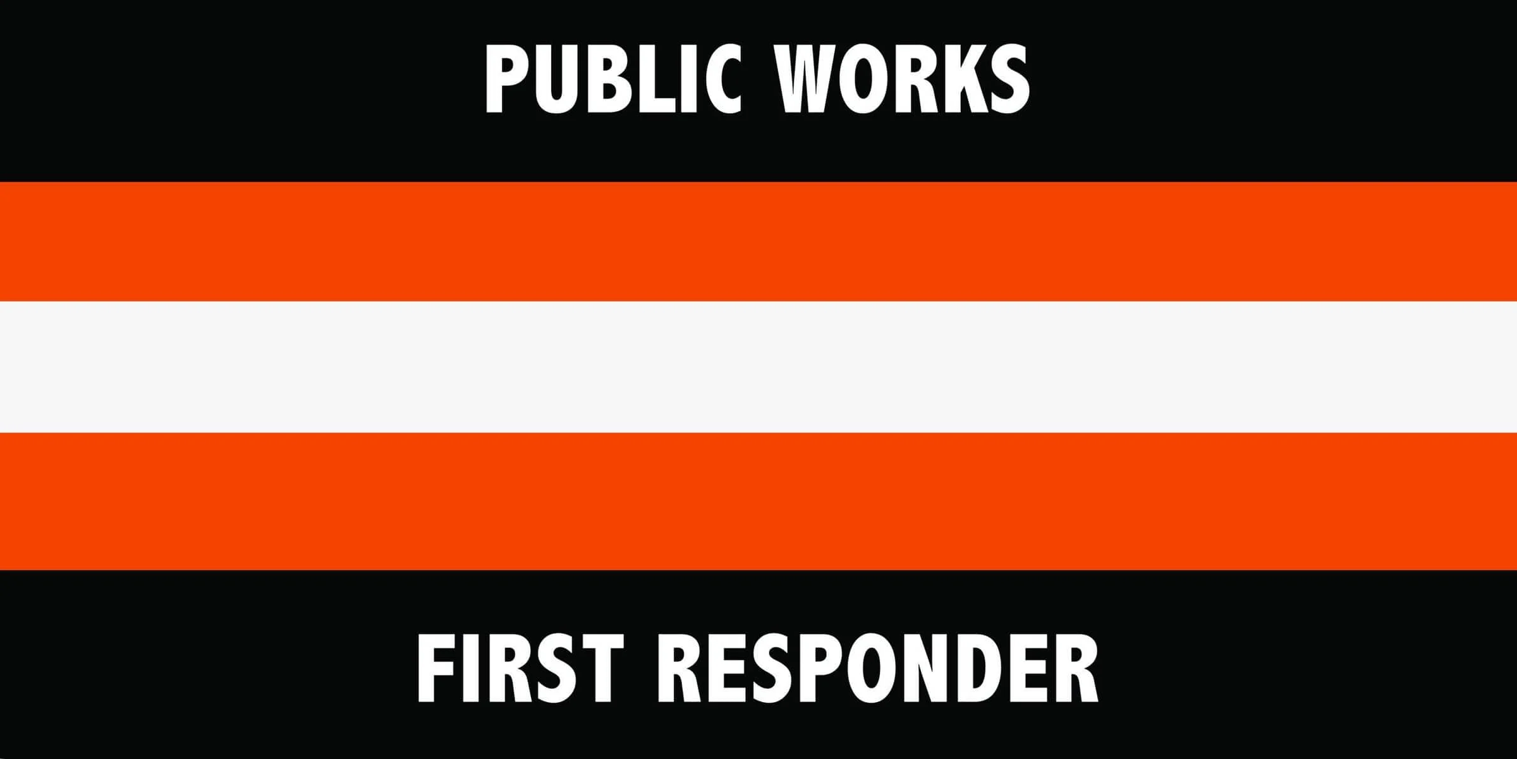

National First Responders Day Proclamation (SAMPLE)

October 28, 2024

WHEREAS, first responders—including public works professionals, firefighters, police officers, emergency medical technicians, 911 operators, paramedics, and other emergency personnel—stand on the front lines of our communities, selflessly serving and protecting the citizens of **[INSERT TOWN, CITY OR STATE NAME]** in times of crisis; and,

WHEREAS, first responders respond swiftly and courageously to emergencies, often putting their own lives at risk to ensure the safety and well-being of others, whether in natural disasters, accidents, medical emergencies, or public health and safety threats; and,

WHEREAS, it is in the public interest for the citizens, civic leaders, and children in **[INSERT TOWN, CITY OR STATE NAME]** to gain knowledge of and maintain an ongoing interest and understanding of the importance of public works and other first responder efforts in their respective communities; and,

WHEREAS, the year 2024 marks the 6thannual National First Responders Day sponsored by bipartisan resolutions in the US Senate and House be it now,

RESOLVED, I, **[INSERT NAME AND TITLE]**, do hereby designate October 28, 2024, as National First Responders Day. I urge all citizens to join with representatives of the American Public Works Association and government agencies in activities, events, and ceremonies paying tribute to our public works first responders alongside law enforcement, firefighters, paramedics, emergency medical technicians, 911 operators, and other emergency personnel, to recognize the substantial contributions they make to protecting our national health, safety, and advancing the quality of life for all.

IN WITNESS WHEREOF, I have hereunto set my hand and caused the Seal of **[INSERT TOWN, STATE OR CITY, STATE OR NAME OF COUNTY/STATE]** (to be affixed),

DONE at the **[INSERT TOWN OR CITY],** **[INSERT STATE]** this ________ day of ________ 2024.

**[INSERT NAME]**

**[INSERT OFFICIAL SEAL]**