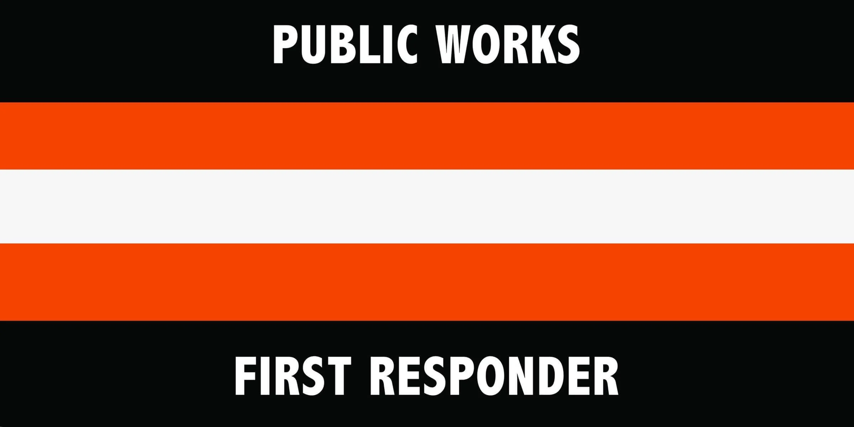
National First Responders Day Proclamation (SAMPLE)
May 1, 2026
WHEREAS, first responders—including public works professionals, firefighters, police officers, emergency medical technicians, 911 operators, paramedics, and other emergency personnel—stand on the front lines of our communities, selflessly serving and protecting the citizens of [INSERT TOWN, MUNICIPALITY, OR PROVINCE/TERRITORY NAME] in times of crisis;
WHEREAS, first responders act swiftly and courageously to emergencies, often putting their own lives at risk to ensure the safety and well-being of others, whether in natural disasters, accidents, medical emergencies, or public health and safety threats;
WHEREAS, it is in the public interest for the citizens, civic leaders, and children in [INSERT TOWN, MUNICIPALITY, OR PROVINCE/TERRITORY NAME] to gain knowledge of and maintain an ongoing interest and understanding of the importance of public works and other first responder efforts in their respective communities; and
WHEREAS, as of 2013, May 1 has been recognized as National First Responders Day in Canada, be it now,
RESOLVED, I, [INSERT NAME AND TITLE], do hereby recognize May 1, 2026, as National First Responders Day. I urge all citizens to join with representatives of the Canadian Public Work Association and government agencies in activities, events, and ceremonies paying tribute to our public works first responders alongside law enforcement, firefighters, paramedics, emergency medical technicians, 911 operators, and other emergency personnel, to recognize the substantial contributions they make to protecting our national health, safety, and advancing the quality of life for all.
IN WITNESS WHEREOF, I have hereunto set my hand and caused the Seal of [INSERT PROVINCE/TERRITORY] (to be affixed),
DONE at the [INSERT TOWN OR MUNICIPALITY], [INSERT PROVINCE/TERRITORY] this ________ day of ________ 2026.
[INSERT NAME]
[INSERT OFFICIAL SEAL]

