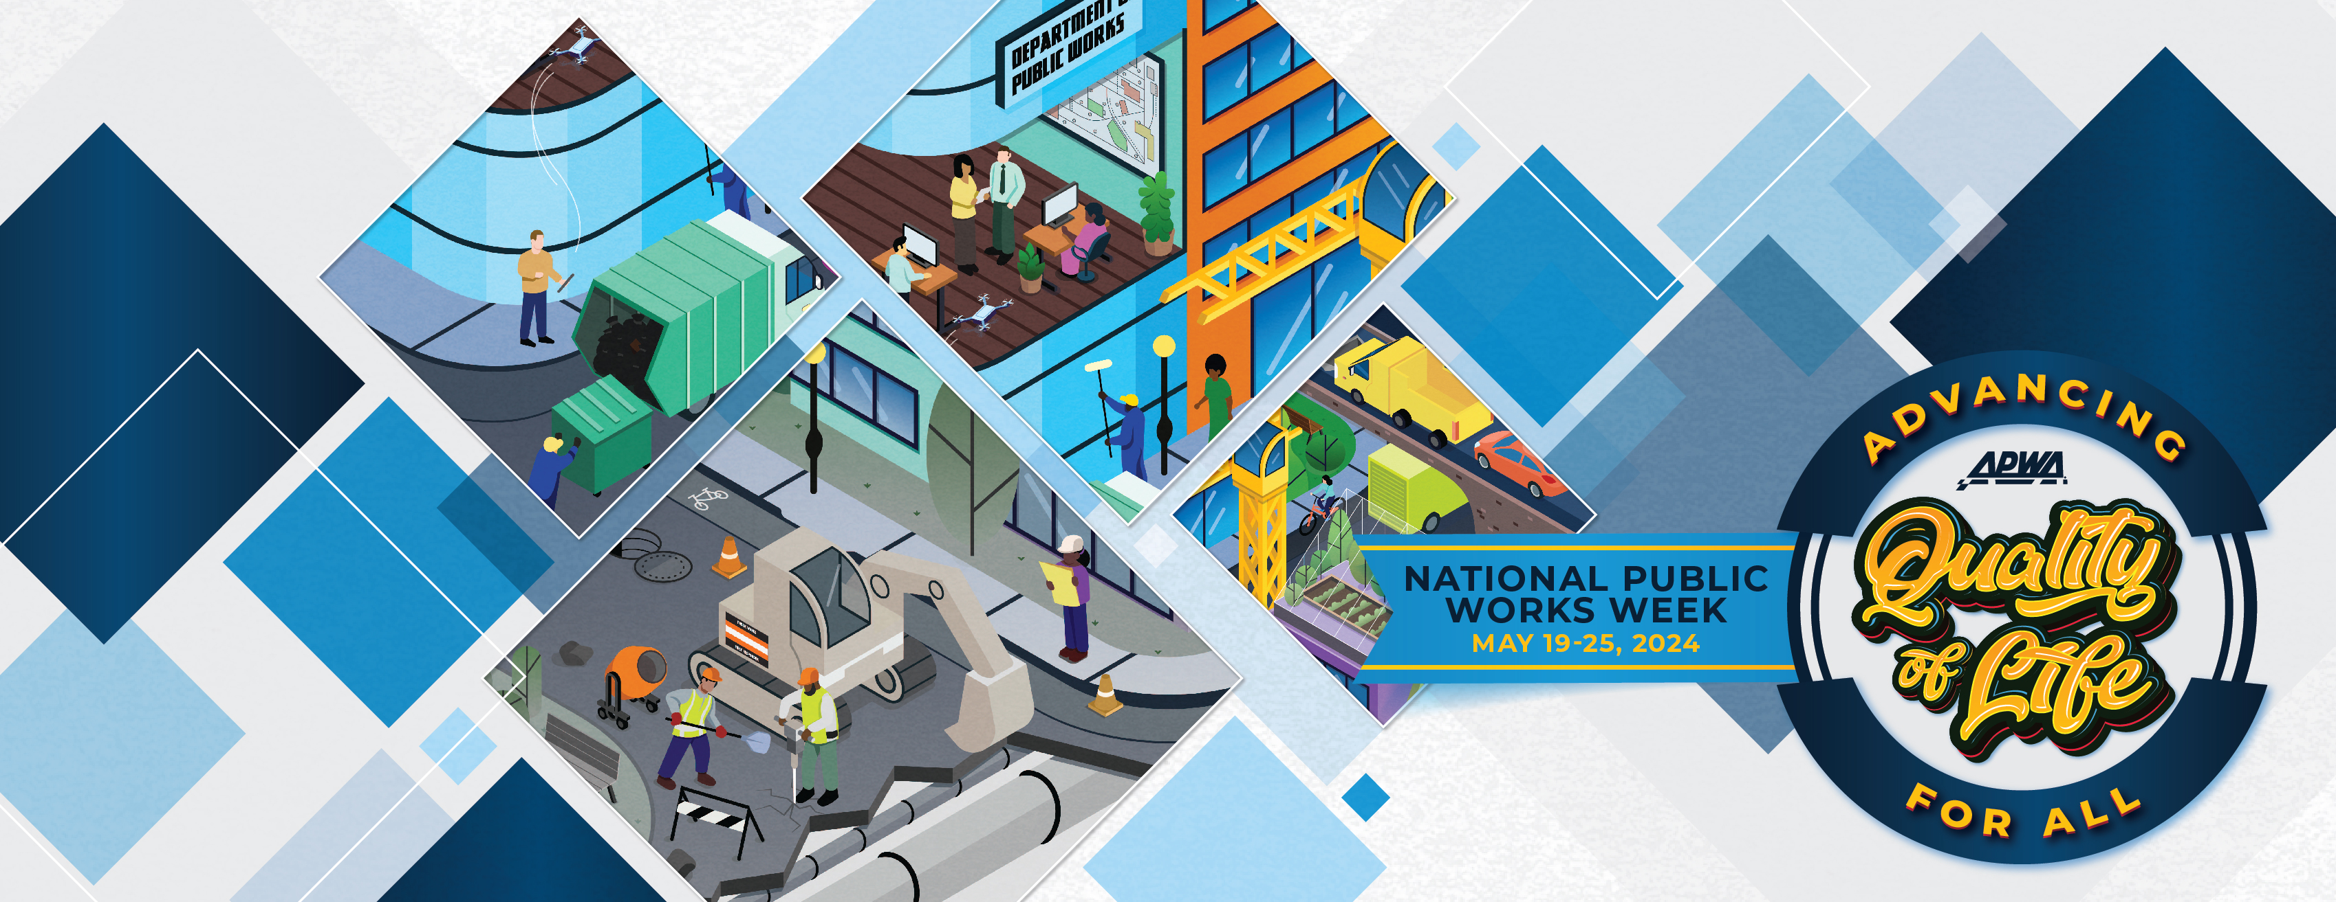
National Public Works Week Proclamation (SAMPLE)
May 19–25, 2024
“Advancing Quality of Life For All”
WHEREAS, public works professionals focus on infrastructure, facilities, and services that are of vital importance to sustainable and resilient communities and to the public health, high quality of life, and well-being of the people of [INSERT CITY NAME OR STATE NAME]; and,
WHEREAS, these infrastructure, facilities, and services could not be provided without the dedicated efforts of public works professionals, who are engineers, managers, and employees at all levels of government and the private sector, who are responsible for rebuilding, improving, and protecting our nation’s transportation, water supply, water treatment and solid waste systems, public buildings, and other structures and facilities essential for our citizens; and,
WHEREAS, it is in the public interest for the citizens, civic leaders, and children in [INSERT CITY NAME OR STATE NAME] to gain knowledge of and maintain an ongoing interest and understanding of the importance of public works and public works programs in their respective communities; and,
WHEREAS, the year 2024 marks the 64th annual National Public Works Week sponsored by the American Public Works Association/Canadian Public Works Association be it now,
RESOLVED, I, [INSERT NAME AND TITLE], do hereby designate the week May 19–25, 2024, as National Public Works Week. I urge all citizens to join with representatives of the American Public Works Association and government agencies in activities, events, and ceremonies designed to pay tribute to our public works professionals, engineers, managers, and employees and to recognize the substantial contributions they make to protecting our national health, safety, and advancing quality of life for all.
IN WITNESS WHEREOF, I have hereunto set my hand and caused the Seal of the State (to be affixed),
DONE at the [INSERT CITY], [INSERT STATE] this ________ day of ________ 2024.
[INSERT NAME]
[INSERT OFFICIAL SEAL]

