[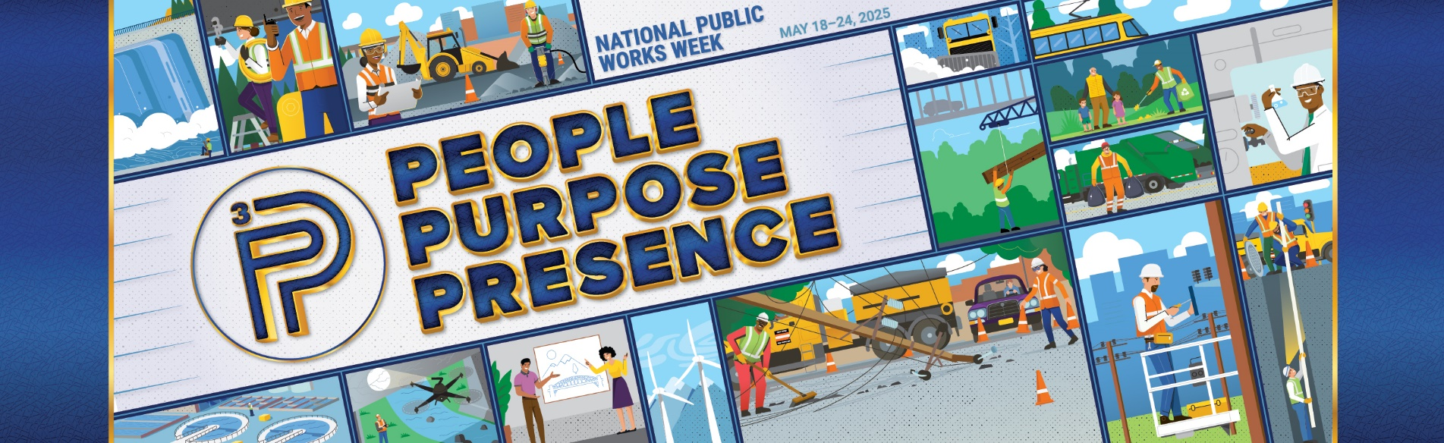](https://www.apwa.org/events/national-public-works-week-npww/npww-downloads/)

**APWA 2025 National Public Works Week Social Media Toolkit**

APWA is proud to announce the 2025 National Public Works Week’s (NPWW) theme of "**People, Purpose, Presence.**" Meeting the needs of people is what gives public works its sense of purpose. And many times, public works professionals will never meet those whose lives have been impacted because when things are going right, no one knows that public works is there. With or without fanfare, public works is ever present, working in the background to advance quality of life for all.

This National Public Works Week (May 18-24), we want to give you the tools to make social media just a bit easier. In this toolkit you’ll find ideas, posts, and pictures to enhance your agency’s social media efforts. Make sure to use **#NPWW** on all your National Public Works Week social media posts. By doing so, you’ll join in on all the NPWW discussions being held across all the major social media platforms, and it will make your posts easier for others to find. If you’re looking to add a little something extra to your post, consider using the following hashtags to tie in with this year’s theme: #people, #purpose, #presence, #PPP, #WeArePublicWorks, #PeopleMatter, #PublicWorksPresence

Within this toolkit you’ll find open-ended ideas to get you started, suggested posts you can use on social media, information on #NPWW Spirit Week, and downloadable images that you can use. A little prep work goes a long way, so schedule some posts ahead of time and enjoy NPWW!

**Ideas to Get You Started**

* Embrace the group selfie! Share a photo or video showing your department at work in the community and encourage your friends and colleagues across the nation to do the same.
* Update your profile pic or Zoom background with a graphic of the NPWW poster art. Downloadable artwork is available [here](https://www.apwa.org/events/national-public-works-week-npww/npww-downloads/).
* Recognize your colleagues who are doing incredible things in the field by shouting them out. Use hashtag #PeopleMatter.
* Dig through the archives! We want to see your unique public works historical pictures.
* What gives you #purpose in public works? Gather stories from within your department. Public workers have some great stories—this is a great time to tell them. Use hashtag #purpose.
* Flex a little bit! This is your time to show off the quality of life you bring to your community! Tell us about clean water, green energy initiatives, and more.
* You’re out there every day improving the quality of life for your community. Follow a day in the life of a crew member to let people see all the hard work you do! Use hashtag #PeopleMatter.
* Focus on the presence that public works has in your community. Show off the things that folks don’t expect you to take care of, like installing new playground equipment or setting up barricades for a parade.
* This is a great week to run a campaign encouraging your residents to point you out! Have residents tag you in pictures of their favorite street signs, public parks, or projects and repost them to your own pages as the #presence of public works! Ask them to use hashtag #presence.

**Suggested Copy for Social Media**

* National Public Works Week is May 18–24! This week we’re taking public works to the third power by sharing how we’re defined by people, purpose, and presence. #NPWW
* During #NPWW, we’re celebrating all things public works, including the paths we took to get here! [This is a great place for video or testimonials from your staff]
* The power of public works is in its trifecta of people, purpose, and presence. #NPWW [include a photo of your team]
* Public works is all around you! Join us in celebrating National Public Works Week #NPWW
* The [town/city name] public works department is celebrating #NPWW! Join us at [community event].
* Do you know the signs of public works? Tag us in pictures of your favorite street signs! #presence of public works
* Public works is always present in your community. [we recommend having fun with graphics like the example below]

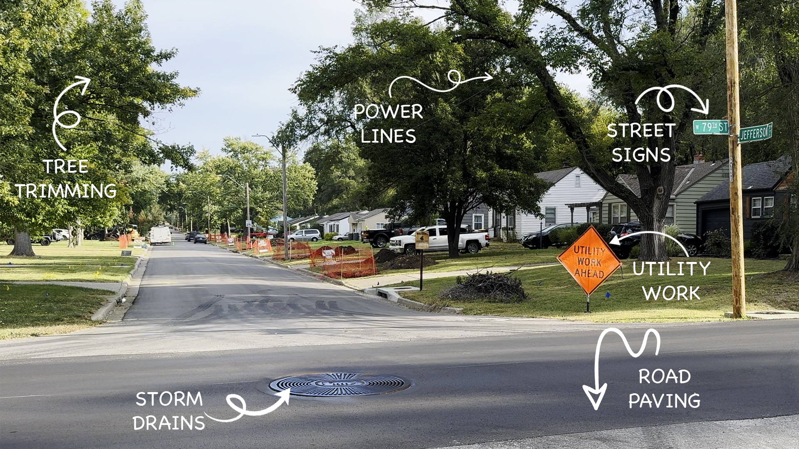

**#NPWW Spirit Week**

Each day of National Public Works Week, APWA will be hosting a Spirit Day on social media. Below, you’ll find information for each day as well as sample posts you can use on social media to get involved. Remember, feel free to adjust these as you need to fit your agency or company’s voice.

**Monday (People, Purpose, Presence)**

How is your department celebrating National Public Works Week? Post a picture that shows the ways your team is motivated by a sense of purpose and is always present when work needs to be done to keep you community safe, clean, and vibrant. . Monday is great for department photos or for showcasing the breadth of your public works department. Why do you do what you do? What gets you out of bed in the morning? What would people be surprised to know is in public works’ wheelhouse? You’re the stars this week!

It’s a great time for an X thread talking about each department in your agency, or to show off your weekly staff meeting. Don’t forget to let the public know about any events your department has going on this week.

Sample post:

“National Public Works Week is May 18–24! This week we’re taking public works to the third power by celebrating how we’re defined by people, purpose, and presence. #NPWW”

**Tuesday (I ❤️ Public Works Because…)**

Tuesday’s the time to let your staff and their hard work shine! This is a great day to highlight why your employees love public works. If you’re doing a community event, make sure to grab photos with the I ❤️ Public Works sign out in public! A ready-to-use sign is available to download [here](https://www.apwa.org/events/national-public-works-week-npww/npww-downloads/).

Sample post:

“We’re highlighting the #purpose that brought our employees into public works today!” Use hashtag: #WeHeartPublicWorks.

**Wednesday (Whatcha Wearing?)**

Wednesday is all about what you wear when you do your job. Show off your waders, safety vest, or hard hat. It’s a great time to highlight the different uniforms in your department. What’s the story behind them? Tell us about it!

Sample posts:

“We don’t wear a suit and tie every day, but our drip is just as slick! #NPWW”

“Do you know the meaning behind the color of our vests? #presence”

**Thursday (Throwback Thursday)**

Where’s your “memory lane”?

Thursday’s Spirit Day is a classic—Throwback Thursday! Public works departments have a long history, so scour the archives and find something neat to share. Remember to use #NPWW and #TBT for today. A few suggestions to get you started:

* An older public works building. Where was your department first located?
* How much has your department grown over the years? This is a great time to show off a staff picture from years past.
* How did your department deal with a large weather event? Throwback to your department clearing the roads, preparing for floods, etc.

Sample post:

“Remember how our community recovered after [Insert natural disaster/emergency situation]? We sure do! #NPWW”

**Friday** **(Future Friday and Foundation Friday)**

We've got two Spirit Day activities to wrap up the week: Future Friday and Foundation Friday! For Future Friday we want to focus on what’s coming next for your agency. Don’t forget the #NPWW and #FutureFriday hashtags. Second, let's wrap up the week by giving back to the industry we love by supporting Foundation Friday! Donate to the APWA Foundation and share out using hashtag #FoundationFriday!

For #FutureFriday, here are a few suggestions to get you started:

* Is there a new public transportation system project on the horizon? Or maybe one you’re already currently working on?
* Is your department moving to a new facility?
* This is your time to get people in your community excited about the projects your team is working on. Examples might be internet infrastructure, new interstate developments, or a new park installation within the city, really anything!

Sample posts for Future Friday and Foundation Friday:

“#NPWW may be coming to an end, but public works has a #presence that never sleeps! We’re looking forward to breaking ground on [EXAMPLE PROJECT] soon.”

“We’re building [PUBLIC TRANSPO SYSTEM] on the off chance that flying cars don’t get invented for another 50 years.”

“We’re wrapping up #NPWW by giving back to the industry we love by supporting the APWA Foundation this #FoundationFriday!”

**Image Assets for Social Media**

Square images are good for Instagram and Facebook, while rectangular images work on X, LinkedIn, and Facebook. All these and more are available on **our website** (Instagram, poster, X banner, Zoom background). [Click here to find downloadable materials.](https://www.apwa.org/events/national-public-works-week-npww/npww-downloads/)

[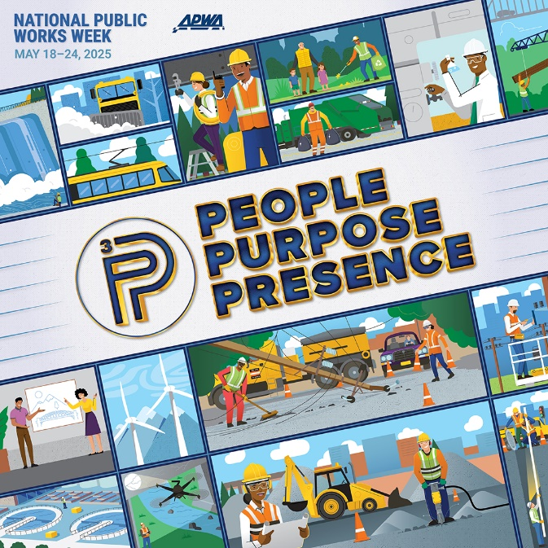](https://www.apwa.org/events/national-public-works-week-npww/npww-downloads/) (Instagram 1080x1080)

[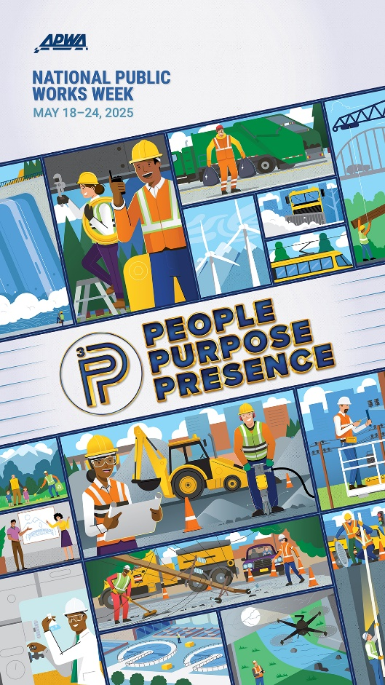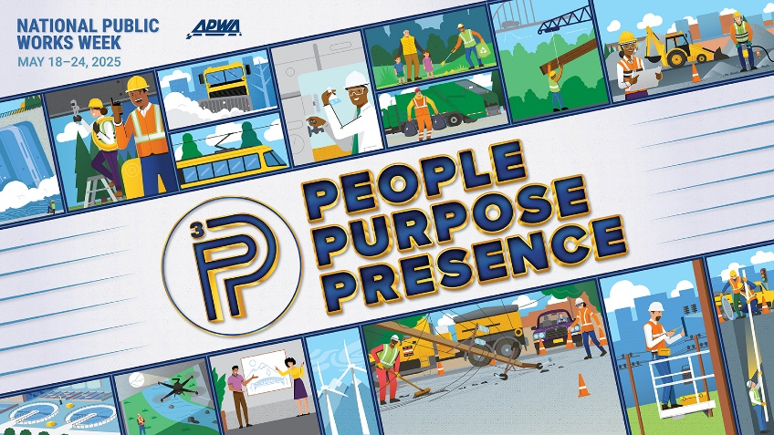](https://www.apwa.org/events/national-public-works-week-npww/npww-downloads/)(X 1600x900) (Instagram 1080x1920)

[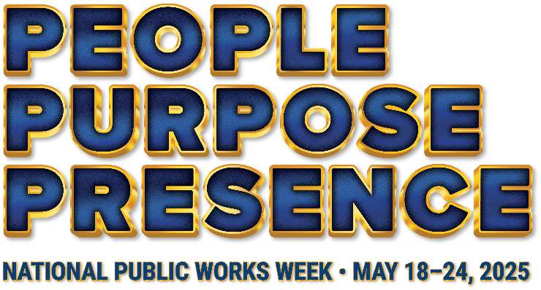](https://www.apwa.org/events/national-public-works-week-npww/npww-downloads/)

**Additional Resources**

Visit APWA’s National Public Works Week [webpages](https://npww.apwa.net/npww/resources.aspx) for more promotional materials! You’ll find

* More graphics
* A link to purchase the 2025 NPWW poster
* How-To Guides (Virtual and In Person)
* Sample proclamations for US and Canada

To follow APWA’s social media channels, go to: [linktr.ee/apwasocial](http://linktr.ee/apwasocial)