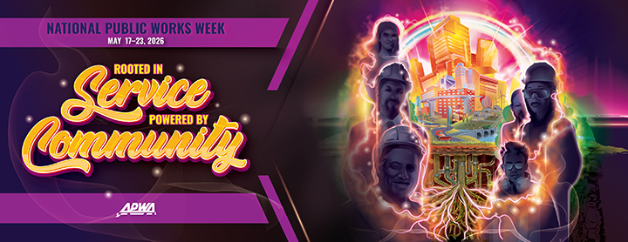
APWA 2026 National Public Works Week Social Media Toolkit
This year's theme, “Rooted in Service, Powered by Community” acknowledges that the roots of service run deep in public works. It’s what has propelled public works innovations that have helped our communities evolve into places where people can lead lives of purpose and possibility. Some work—like building roads and bridges—is highly visible, while other public works contributions—like maintaining water and sewer systems—are sometimes hidden from view. Together, these efforts form the foundation of thriving communities, reminding us that every project, seen or unseen, powers the connection between service and the people it supports.
This National Public Works Week (May 17–23), we want to give you the tools to make social media easier. In this toolkit, you’ll find ideas, posts, and pictures to enhance your agency’s social media efforts. Make sure to use #NPWW on all your National Public Works Week social media posts. By doing so, your content will be pulled into our social media gallery wall that will be live on this webpage in early April, and it will make your posts easier for others to find. If you’re looking to add something extra to your post, consider using the following hashtags to tie in with this year’s theme: #PoweredbyCommunity, #RootedinService, #WeArePublicWorks, #PeopleMatter, #PublicWorksService, among others.
The toolkit will also provide you with open-ended ideas to get you started, suggested posts you can use on social media, information on #NPWW Spirit Week, and downloadable images that you can use. A little prep work goes a long way, so schedule some posts ahead of time and enjoy NPWW!
Ideas to Get You Started
- Embrace the group selfie! Share a photo or video showing your department at work in the community and encourage your friends and colleagues across the nation to do the same.
- Update your profile pic or Zoom background with a graphic of the NPWW poster art. Downloadable artwork is available here.
- Recognize your colleagues who are doing incredible things in the field by shouting them out. Use hashtag #RootedinService.
- Dig through the archives! We want to see your unique public works historical pictures. Show off your city’s first stop light. Or showcase what your downtown streets looked like 100 years ago.
- What gives you purpose in public works? Gather stories from within your department. Public workers have some great stories—this is a great time to tell them. Use hashtag #RootedinService.
- Flex a little bit! This is your time to show off the quality of life you bring to your community! Tell us about clean water, green energy initiatives, new parks opened, bridges repaired, and more.
- You’re out there every day improving the quality of life for your community. Follow a day in the life of a crew member to let people see all the hard work you do! Use hashtag #PoweredbyCommunity.
- Focus on the presence that public works has in your community. Show off the things that folks don’t expect you to take care of, like installing new playground equipment or setting up barricades for a parade.
- This is a great week to run a campaign encouraging your residents to point out your agency! Have residents, family, and friends tag your public works accounts in pictures of their favorite street signs, public parks, or projects and repost them to your own pages showing how you’re #PoweredbyCommunity! Ask them to use hashtag #PoweredbyCommunity in their posts.
Suggested Copy for General NPWW Posts
- National Public Works Week is May 17–23! This week we’re demonstrating how public works is always #RootedinService and #PoweredbyCommunity. #NPWW
- During #NPWW, we’re celebrating all things public works, including the paths we took to get here! [This is a great place for video or testimonials from your staff]
- The power of public works is its willingness to selflessly serve their communities. #NPWW [include a photo of your team]
- Public works is all around you! Join us in celebrating National Public Works Week #NPWW
- The [town/city name] public works department is celebrating #NPWW! Join us at [community event].
- Do you know the signs of public works? Tag us in pictures of your favorite street signs! #PoweredbyCommunity
- Public works is always present in your community. [We recommend having fun with graphics like the following example.]
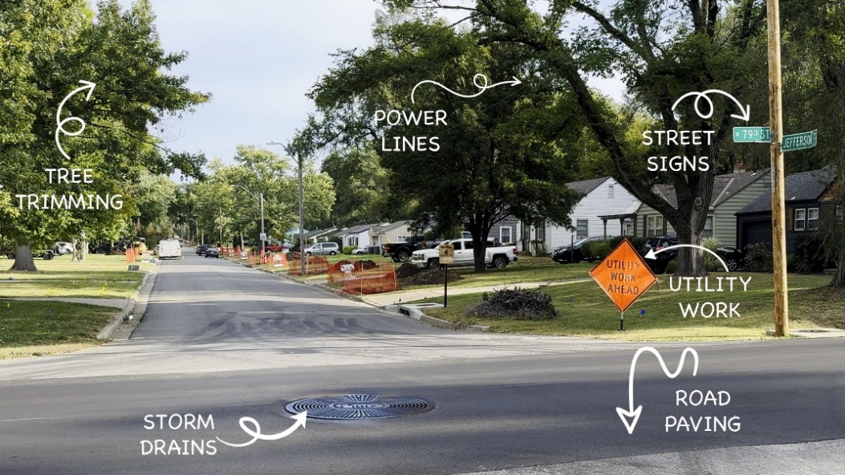
#NPWW Spirit Week
Each day of National Public Works Week, APWA will be hosting a Spirit Day on social media. Below, you’ll find information for Monday through Friday as well as sample posts you can use on social media to get involved. Remember, feel free to adjust these as you need to fit your agency or company’s voice.

Monday (Rooted in Service, Powered by Community)
How is your department celebrating National Public Works Week? Post a picture that shows the ways your team is motivated by their dedication to the communities they serve and are always present when work needs to be done to keep your community safe, clean, and vibrant. Monday is great for department photos or for showcasing the breadth of your public works department. Why do you do what you do? What gets you out of bed in the morning? What would people be surprised to know is in the public works wheelhouse? You’re the stars this week!
It’s a great time for posting short videos talking about each department in your agency, or to show off your weekly staff meeting. Don’t forget to let the public know about any events your department has going on this week.
Sample posts:
“National Public Works Week is May 17–23! This week we’re demonstrating how public works is always #RootedinService and #PoweredbyCommunity. #NPWW”
“The roots of our service run deep. Join us on [INSERT DATE AND TIME] for our [INSERT EVENT DETAILS]. We can’t wait to celebrate National Public Works Week with you! #NPWW”
Tuesday (I ❤️ Public Works Because…)
Tuesday’s the time to let your staff and their hard work shine! This is a great day to highlight why your employees love public works. Have your team fill out the I ❤️ Public Works sign. Post a collection of signs or ask your employees to post their sign on their own feed. If you’re doing a community event, make sure to ask members of the public to fill out the I ❤️ Public Works sign and snap photos with them holding it! A ready-to-use sign is available to download here.
Sample post:
“We’re highlighting how our employees are #RootedinService! #WeHeartPublicWorks.”
“We’re highlighting messages from the people we serve. Thank you to all who came out for today’s [INSERT EVENT NAME] and for sharing your love of public works! “WeHeartPublicWorks.”
Wednesday (Whatcha Wearing?)
Wednesday is all about what you wear when you do your job. Show off your waders, safety vest, or hard hat. It’s a great time to highlight the different uniforms in your department or your agency’s logo on branded items. (Don’t forget to include your office staff!). What’s the story behind them? Tell us about it!
Sample posts:
“We don’t wear a suit and tie every day, but our drip is just as slick! #NPWW”
“Do you know the meaning behind the color of our vests? #NPWW”
“[INSERT INDIVIDUAL OR DEPARTMENT NAME] is proud to wear the [insert agency name] logo! #RootedInService”

Thursday (Throwback Thursday)
Where’s your “memory lane?”
Thursday’s Spirit Day is a classic—Throwback Thursday! Public works departments have a long history, so scour the archives and find something neat to share. Remember to use #NPWW and #TBT for today. A few suggestions to get you started:
- An older public works building. Where was your department first located?
- How much has your department grown over the years? This is a great time to show off a staff picture from years past.
- How did your department deal with a large weather event? Throwback to your department clearing the roads, preparing for floods, etc.
- Where was your city’s first stop light installed? Share comparison photos of what the intersection looked like decades ago and now today.
- How many miles of streets did your snowfighters plow 100 years ago? How does that compare to today? Share a then and now graph.
Sample posts:
“Our public works agency got its start in [INSERT YEAR], and, boy, have we grown by leaps and bounds! Check out our first headquarters and where we call home today. #NPWW #TBT
“Our public workers really showed how they were #PoweredbyCommunity in the way they recovered from [INSERT EMERGENCY EVENT DETAILS]. #RootedinService #FirstResponders #NPWW”
“Did you know that in 1926, our snowplows had to cover [INSERT NUMBER OF MILES] of roads? And today that number is closer to [INSERT NUMBER OF MILES]! No matter the miles, we love having the chance to serve our community. #NPWW #TBT #PoweredByCommunity”
Friday (Future Friday)
Let’s celebrate the future by highlighting upcoming projects that your team will be working on in the next twelve months.
- Is there a new public transportation system project on the horizon? Or maybe one you’re currently working on?
- This is your time to get people in your community excited about the projects your team is working on. Examples might be internet infrastructure, new interstate developments, or a new park installation within the city, it can be anything!
Another idea is to celebrate your agency’s impact on the next generation. You might consider visiting a local school, youth group, or community center and hosting a short demo or Q&A about what public works does. Invite kids or teens to draw, write, or share what they think the “future of their community” looks like. Capture photos or short video clips of the interaction (with appropriate permissions) and share your favorites on social media.
Use hashtags like #NPWW, #FutureFriday, and #PoweredByCommunity.
Sample posts for Future Friday:
“#NPWW may be coming to an end, but public works never sleeps! We’re looking forward to breaking ground on [EXAMPLE PROJECT] soon. #NPWW #FutureFriday”
“We’re building [PUBLIC TRANSPO SYSTEM] on the off chance that flying cars don’t get invented for another 50 years. #NPWW #FutureFriday”
“Today we spent time with some bright young minds at [INSERT HOST FACILITY NAME], sharing what public works is all about—from the roads they ride on to the parks where they play. Swipe through to see a few of our favorite moments from today’s visit. We’re proud to be #RootedInService and excited to help shape the future right alongside them. #NPWW #PoweredByCommunity”

Image Assets for Social Media
For Instagram, images should be optimized for a 4:5 ratio, while anything with a 16:9 ratio will work on X, LinkedIn, and Facebook. All these and more are available on our website. Click here to find downloadable materials.
Other recommended specs are:
- Facebook - 1200x630 or 1080x1080
- Instagram - 1080 x 1350 (4:5 ratio) for portrait/vertical posts, 1080x1080 (1:1 ratio) for square, or 1080x1920 for Stories
- LinkedIn - 1200x627 or 1080x1080
- X - 1200x675
Additional Resources
Visit APWA’s National Public Works Week web pages for more promotional materials! You’ll find:
- More graphics, including a black and white coloring sheet, Zoom background, and banners of various sizes
- A link to purchase the 2026 NPWW poster
- How-To Guides (Virtual and In-Person)
- Sample proclamations for US and Canada
To follow APWA’s social media channels, go to: linktr.ee/apwasocial

